ISTM-622 Project Gigavolt: Milestone 4
Text Chunking, Embedding Generation & Vector Database
~ Atharva Kedar

1. Overview & Video Link
Milestone 4 extends Project Gigavolt from relational data management (Milestones 1–3) into a working vector search pipeline. The goal is to convert Gigavolt's unstructured technical documentation (SOPs, manuals, engineering change orders, incident reports, datasheets, audit reports) into dense embeddings and store them in a vector database for fast semantic retrieval.
The whole pipeline was built and run on an AWS Academy EC2 Ubuntu instance inside a Python virtual environment. A single script, gigavolt_m4_pipeline.py, performs recursive document discovery, text extraction, sentence-aware chunking, embedding generation with all-MiniLM-L6-v2, persistent storage in ChromaDB with HNSW settings, interactive similarity search, and benchmarking.
YouTube video link: https://youtu.be/0VCUB-nnAmA
GitHub repository link: https://github.com/aKedar008/Project-Gigavolt.git

2. Objectives and How They Were Met
Objective | Implementation
Chunking engine | Sentence-aware chunking with configurable chunk size (default 384 est. tokens) and overlap (default 64 est. tokens)
Embedding generation | SentenceTransformer("all-MiniLM-L6-v2"), batched, normalized embeddings
Vector database | Persistent ChromaDB collection gigavolt_m4
Metadata | Source document, extension, chunk index, estimated tokens, character count, ingestion timestamp
HNSW indexing | Cosine space, M = 16, ef_construction = 200, ef_search = 50
Benchmarking | Mean, P50, P95, P99 retrieval latency and recall@5 against exact cosine search
Demonstration | Live semantic queries over the Gigavolt documents

3. AWS EC2 Environment
The instance was launched with a user-data script that:
- installed MariaDB 11.8 and base packages (python3-pip, python3-venv, wget, curl, unzip);
- created the Python virtual environment at /opt/vector_env, with pip temp files routed to /var/tmp to avoid filling RAM-backed /tmp;
- installed CPU-only PyTorch first, then sentence-transformers, pymysql and numpy;
- downloaded and unzipped the Gigavolt unstructured data into /opt/gigavolt-milestone4/data;
- added source /opt/vector_env/bin/activate to the ubuntu user's .bashrc.
An earlier attempt that installed the default PyTorch build failed with No space left on device. Switching to the CPU-only wheel with --no-cache-dir avoided this.
Packages installed manually afterwards:
pip install --no-cache-dir chromadb pypdf PyPDF2 python-docx beautifulsoup4 lxml pandas scikit-learn tqdm
The instance had about 908 MiB of RAM, which shaped several later decisions (see Section 13).

4. Data Acquisition
Data source: https://622.gomillion.org/data/UnstructuredData.zip, extracted to /opt/gigavolt-milestone4/data.
The pipeline scans this folder recursively and accepts .pdf, .txt, .md, .csv, .json, .html, .htm, .xml, .docx, .log, .sql. For this dataset it found 25 supported documents, all PDFs, which produced 29 chunks.

5. Pipeline Architecture
The script has three modes:
python gigavolt_m4_pipeline.py ingest --rebuild --batch-size 1
python gigavolt_m4_pipeline.py search
python gigavolt_m4_pipeline.py benchmark
Ingest: discover documents, extract text, chunk, embed in batches, insert into ChromaDB with metadata, write ingestion_summary.json.
Search: load the same embedding model, embed the typed query, query ChromaDB for the top-k chunks, print similarity, source, chunk index and snippet, and report embedding time and vector-database search time separately.
Benchmark: run 10 technical queries, 10 runs each, record retrieval latency, compute recall@5 against an exact cosine search over all stored vectors, and write benchmark_results.csv and benchmark_summary.json.

6. Chunking Engine Design
Default parameters: chunk_tokens = 384, overlap_tokens = 64, within the milestone's 256–512 token guidance. Both are command-line configurable.
Steps:
- Normalize whitespace and strip null characters.
- Split text into paragraphs, then into sentences using punctuation-aware rules.
- Estimate tokens as word count × 1.3.
- Add sentences to the current chunk until the target size would be exceeded.
- Start the next chunk with trailing sentences from the previous one, up to the overlap budget.
- If a single sentence or table row exceeds the target, split it by words so no chunk grows unbounded.
This replaced the earlier script's fixed-size character chunks (500 characters, 50 overlap), which could split mid-sentence. Sentence-aware chunking matters here because the documents contain fault codes, part numbers and procedure steps that lose meaning when cut apart.
Limitation: token counts are estimated from word counts rather than produced by the model's real tokenizer, so actual token counts can differ somewhat from the target. Chunk counts also depend on this method, the PDF parser and the chunking logic, which is why another implementation using the same 384/64 settings can produce a different number of chunks (for example 42 instead of 29).

7. Embedding Generation
Model: all-MiniLM-L6-v2 via SentenceTransformers (384-dimensional vectors, normalized). It is small enough to run on a CPU-only instance and gives good semantic quality for technical text.
Chunks are embedded in batches. Batch size only controls how many chunks are embedded at once; it does not change which data is processed. The successful run used --batch-size 1, which is slowest but lowest in memory. The run still processed all 25 documents and stored all 29 chunks.

8. ChromaDB and HNSW Configuration
ChromaDB was chosen because it is a Python library with no separate server, which suits a single small EC2 instance and keeps the focus on vector search.
- Persistent path: /opt/gigavolt-milestone4/chroma_db
- Collection: gigavolt_m4
- Stored per chunk: ID (SHA-1 of source, index and text prefix), text, embedding, and the metadata fields listed in Section 2.
Parameter | Value | Role
hnsw:space | cosine | Distance metric for semantic similarity
hnsw:M | 16 | Graph connections per node; higher improves recall but uses more memory
hnsw:construction_ef | 200 | Build-time search breadth; higher gives better index quality but slower build
hnsw:search_ef | 50 | Query-time search breadth; higher improves recall but can raise latency
Note on tuning: one configuration (16 / 200 / 50) was built and benchmarked. With only 29 vectors this already reached perfect recall, so a sweep of different M, ef_construction and ef_search values would show little difference at this scale. The parameters are command-line configurable (--hnsw-m, --hnsw-ef-construction, --hnsw-ef-search) so a sweep can be run if a larger dataset is used.

9. Interactive Similarity Search
The collection held 29 vectors. Example queries and top results:
Query | Top result | Similarity | Vector DB search time
chiller compressor overload | GV-SOP-HVAC-310 SOP PowerStation Chiller and Refrigerant.pdf | 0.5484 | 14.99 ms
battery maintenance procedure | GV-SOP-DECOM-601 SOP EOL Decomissioning.pdf | 0.5289 | 5.61 ms
warranty claim denial reason | GV-SOP-WAR-101 SOP Field Warranty Claims.pdf | 0.3850 | 3.44 ms
emergency response fire safety | GV-SOP-SAFETY-900 SOP BESS Emergency Response and Fire Safety.pdf | 0.5187 | 4.61 ms
cabinet door seal failure | GV-ECO-2024-052 Change Order Cabinet Door Seal.pdf | 0.3244 | 2.71 ms
The chiller query's top snippet directly mentions chiller compressor overload alerts (ERR_HVAC_502), and the G-3500 manual chunk with the same fault code also ranked in the top five. The first query in each session was the slowest (embedding about 450 ms and search about 15 ms) because the model and index were still warming up. Later queries embedded in about 17–20 ms. A deliberately vague query ("gas") returned low similarity scores (0.17 and below), as expected.
Embedding time and vector-database search time are reported separately because the milestone's sub-20 ms target concerns retrieval.

10. Benchmarking Methodology
- 10 queries × 10 runs each = 100 timed retrievals, k = 5.
- Five warm-up queries run first.
- Latency timed around the ChromaDB query call only (embeddings precomputed).
- Recall@5 = overlap between ChromaDB's top-5 IDs and the exact top-5 from a brute-force cosine similarity over all stored vectors, divided by 5.
Queries: inverter fault troubleshooting, battery maintenance procedure, warranty claim denial reason, dispatch technician repair summary, equipment voltage capacity, replacement parts reorder level, customer service record, installation safety procedure, solar panel service issue, preventive maintenance schedule.

11. Benchmark Results
Metric | Value | Target | Result
Mean latency | 1.22 ms | n/a | n/a
P50 latency | 1.19 ms | < 20 ms median | Passed
P95 latency | 1.47 ms | n/a | n/a
P99 latency | 1.56 ms | n/a | n/a
Recall@5 (mean) | 1.0 | > 0.9 | Passed
Recall@5 (minimum) | 1.0 | > 0.9 | Passed
Caveat: these results are for a very small collection (29 chunks). At this size HNSW search is nearly equivalent to an exhaustive scan, so perfect recall and about 1 ms latency are expected and should not be extrapolated to much larger corpora. The benchmark queries are also general phrases rather than a labelled relevance set, so recall here measures agreement with exact search, not human-judged relevance.

12. Design Decisions and Rationale
- ChromaDB: simplest deployment (no server), recommended in the milestone, and light enough for a 908 MiB instance.
- all-MiniLM-L6-v2: compact CPU-friendly model with solid semantic quality; the main trade-off is its short effective input length, which is one reason chunks are kept near 384 tokens.
- Sentence-aware chunking with overlap: keeps procedures and fault-code tables intact and preserves context across boundaries.
- Cosine distance with normalized embeddings: standard choice for sentence embeddings.
- Reduced batch size and added swap: the first ingestion run was killed by the operating system (out of memory). Adding a 4 GB swap file and rerunning with --batch-size 1 fixed it without reducing the dataset.
- Everything on EC2: keeps the database, outputs and logs in one reproducible environment and matches earlier milestones.

13. Challenges and Lessons Learned
Challenge | Cause | Fix
No space left on device during pip install | Default PyTorch wheel is very large; small root disk | CPU-only PyTorch, --no-cache-dir, pip temp dir on /var/tmp
Ingestion printed Killed | Embedding exhausted about 908 MiB RAM | 4 GB swap and --batch-size 1
Hugging Face unauthenticated-request warning | No HF token set | Ignored; the model downloaded successfully
Search appeared "stuck" | Interactive mode waits at the Query: prompt | Type quit to exit instead of Ctrl+C
Friend got 42 chunks, I got 29 | Different chunking logic, token estimation or PDF parser | Documented the method; checked document count and per-document chunk counts
User-data size limit | The full setup script was about 28 KB against a 16 KB limit | Kept user data to environment setup and created the Python script manually after SSH

14. Code Artifacts
File | Purpose
gigavolt_m4_pipeline.py | Chunking, embedding, ChromaDB ingestion, search and benchmark (modes: ingest, search, benchmark)
ingestion_summary.json | Document, chunk and parameter summary for the ingestion run
benchmark_results.csv | Per-run latency and recall for all 100 benchmark runs
benchmark_summary.json | Aggregate latency percentiles and recall
/opt/gigavolt-milestone4/chroma_db | Persistent ChromaDB database
milestone4_benchmark.ipynb | Notebook that loads the CSV and JSON outputs and plots the latency distribution and recall by query (to be created from the benchmark outputs)
Ingestion summary from the final run:
{
"document_count": 25,
"chunk_count": 29,
"collection_count": 29,
"embedding_model": "all-MiniLM-L6-v2",
"chunk_tokens": 384,
"overlap_tokens": 64,
"hnsw_m": 16,
"hnsw_ef_construction": 200,
"hnsw_ef_search": 50,
"elapsed_seconds": 7.19
}

15. 4Ds of AI Fluency

Delegation
I used AI assistance as a technical support tool while working on Milestone 4. AI helped me organize the vector search workflow, understand the milestone requirements, refine the chunking and embedding approach, and troubleshoot implementation issues on the AWS EC2 instance. I used AI for guidance, but I made the final decisions about the implementation, testing, and submission artifacts.

Description
I provided AI with the milestone requirements, my existing project context, my earlier chunking script, my EC2 setup approach, terminal outputs, error messages, and benchmark results. By clearly describing the environment and the problems I encountered, I was able to get more relevant support for building the chunking, embedding, ChromaDB ingestion, search, and benchmarking pipeline.

Diligence
I verified the AI-assisted suggestions by running the pipeline directly on the AWS EC2 instance. I checked that the virtual environment was active, the data was downloaded, documents were processed, chunks were generated, embeddings were stored in ChromaDB, and similarity search returned relevant technical documents. I also validated the benchmark outputs for latency and recall before using them in the final documentation.

Discernment

I reviewed AI suggestions carefully before applying them. I adapted the recommendations to fit the AWS Academy environment, especially when dealing with limited memory and storage. For example, I added swap space and reduced the embedding batch size to make the pipeline stable on the EC2 instance. I used AI as a helper for explanation, debugging, and structure, but I evaluated the final results myself before accepting them.

16. Final Summary
The pipeline processed 25 Gigavolt documents into 29 sentence-aware overlapping chunks, embedded them with all-MiniLM-L6-v2, and stored them with metadata in a persistent ChromaDB collection configured with cosine HNSW (M = 16, ef_construction = 200, ef_search = 50). Searches returned relevant SOPs, manuals and change orders for technical queries. The benchmark showed a median retrieval latency of 1.19 ms (target under 20 ms) and recall@5 of 1.0 (target above 0.9). Because the dataset is small, these numbers confirm the pipeline works correctly but do not prove behavior at larger scale.

17. Execution Artifacts
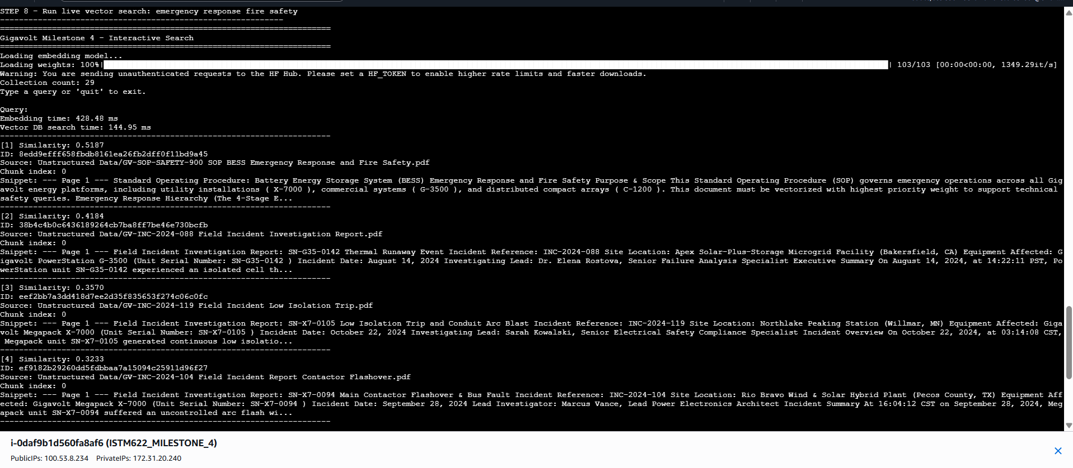
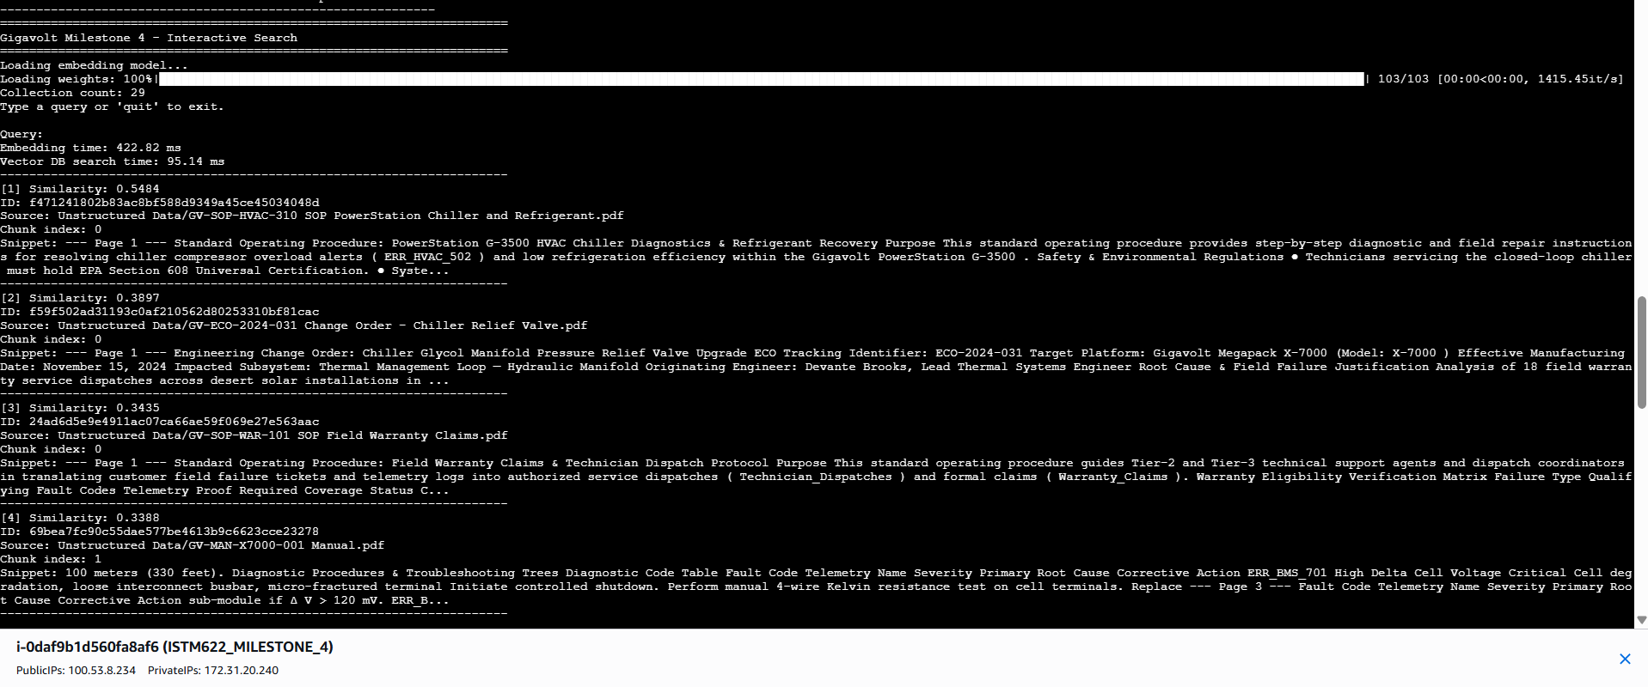
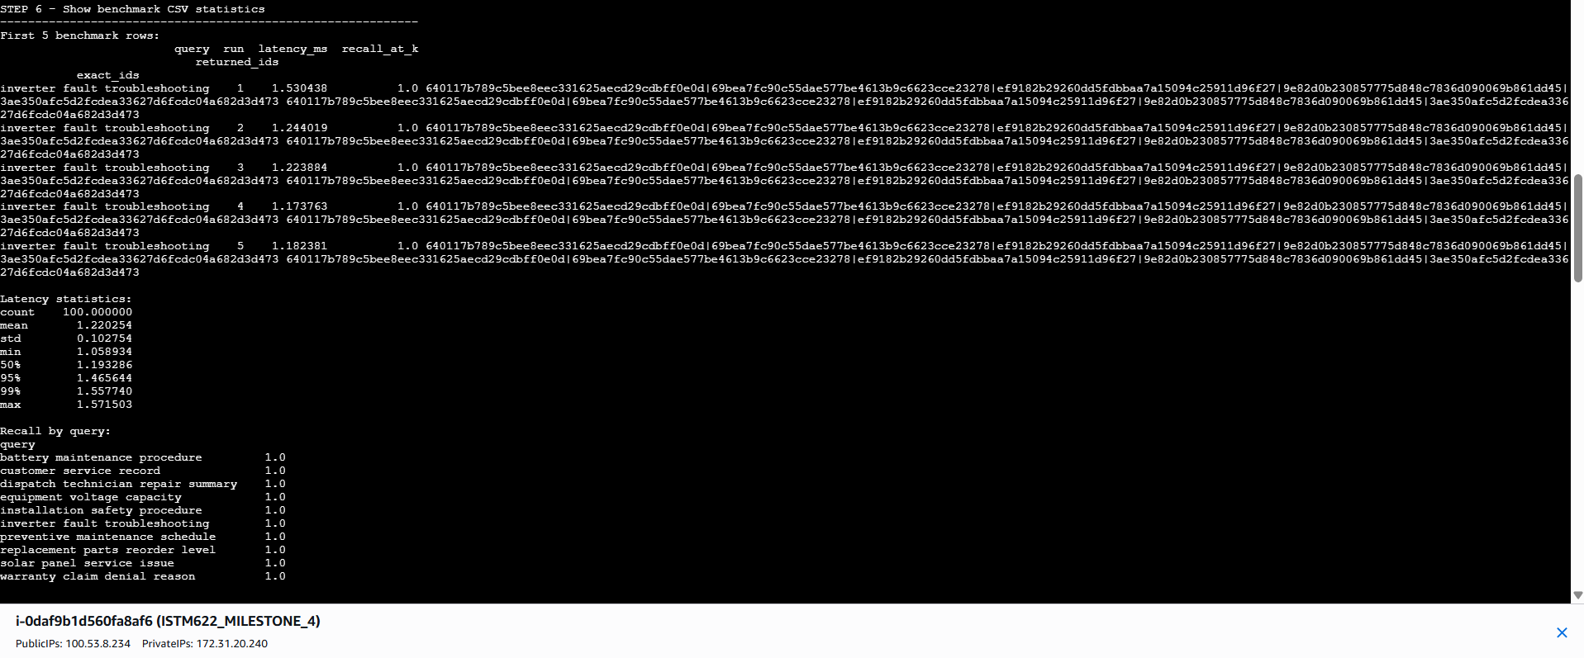
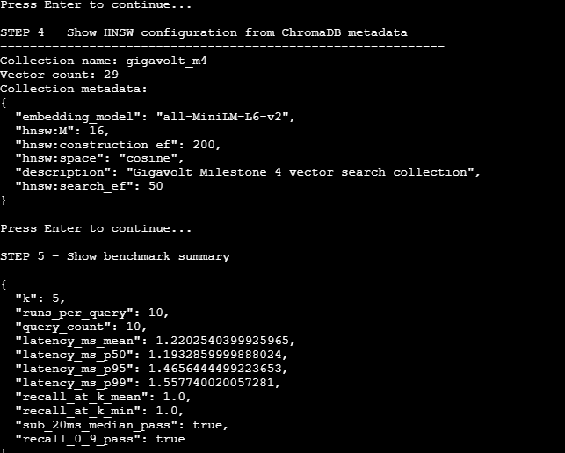
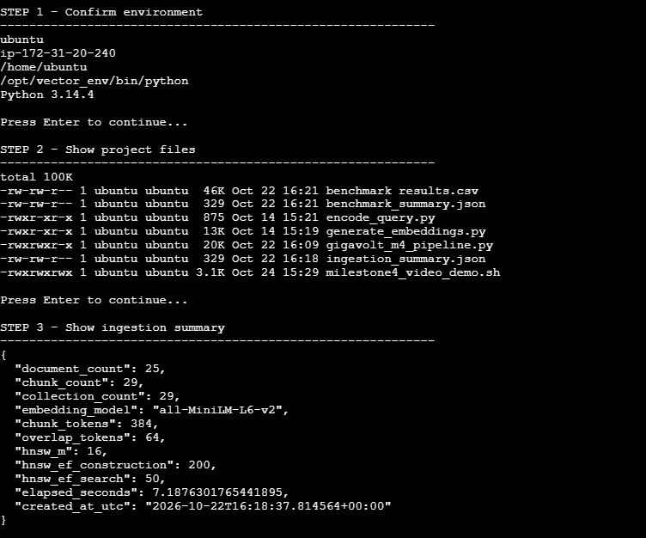
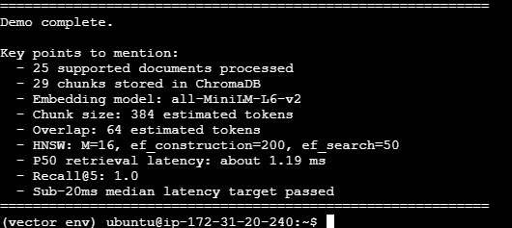

18. Appendix: Key Commands
source /opt/vector_env/bin/activate
# Add swap after the process was killed
sudo fallocate -l 4G /swapfile
sudo chmod 600 /swapfile
sudo mkswap /swapfile
sudo swapon /swapfile
echo '/swapfile none swap sw 0 0' | sudo tee -a /etc/fstab
# Run the pipeline
python gigavolt_m4_pipeline.py ingest --rebuild --batch-size 1
python gigavolt_m4_pipeline.py search
python gigavolt_m4_pipeline.py benchmark
# Per-document chunk counts (for comparing with classmates)
python - <<'PY'
import chromadb
from collections import Counter
c = chromadb.PersistentClient(path="/opt/gigavolt-milestone4/chroma_db").get_collection("gigavolt_m4")
counts = Counter(m["source_document"] for m in c.get(include=["metadatas"])["metadatas"])
for d, n in sorted(counts.items()):
print(n, d)
PY

